## Package the UPCUA Files

In directory with these 2 folders:

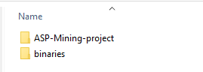

With this tree

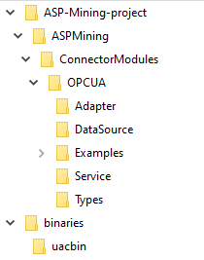

Run:

tar -czvf asp-mining_opcua-package_v0.1.0.tar.gz ASP-Mining-project binaries

Install:

tar -xzvf asp-mining_opcua-package_v0.1.0.tar.gz -C <asp-mining-repo-dir>